PREDICT498 CAPITAL MANAGEMENT

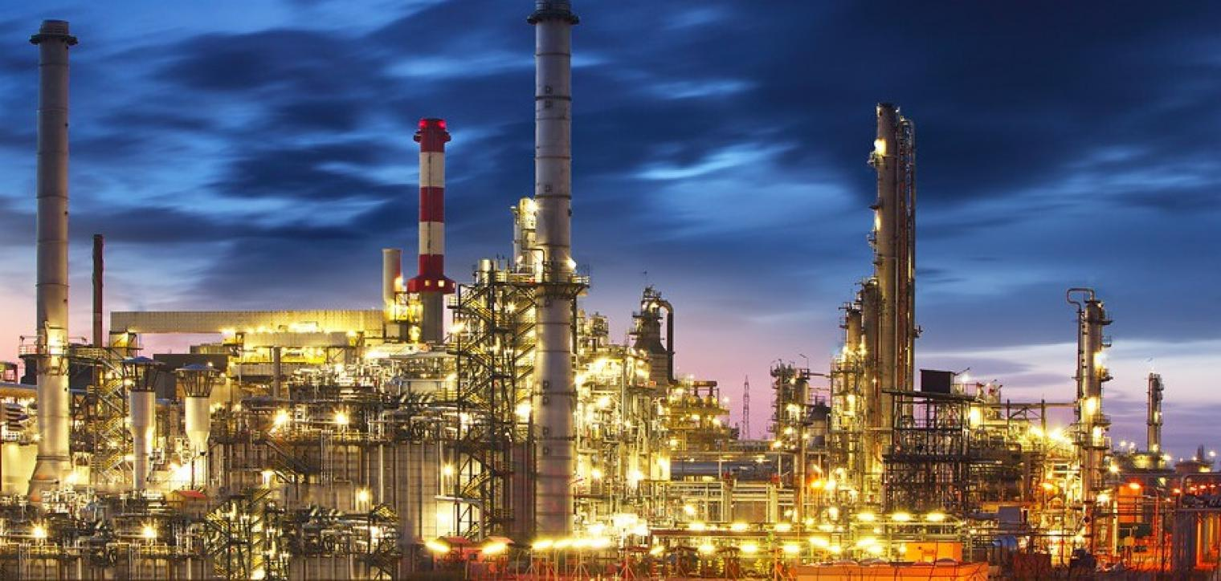

Project Proposal

October 6, 2019

Predict498 Capital LP Team Members

Tate Bolick

Andrius Markvaldas

Brandon Moretz

Joshua Wood

CONTENTS

COMPANY BACKGROUND

Predict498 Capital Management is a private fund management company in fundamental commodity strategies with a specialisation in the oil and energy complex. Predict498 Capital is led by Donald Wedding, one of the world’s most renowned oil and energy traders. The investment strategy targets absolute returns with an asymmetric upside, via detailed supply and demand forecasting, fundamental, macro-economic and physical market information combined with various technical market indicators to generate fair values, forecasts and trading signals for energy and commodities.

Predict498 Capital Management was formed in 2019 by a small group of data scientists and software engineers with the goal optimizing the energy trading frontier with the latest advances in machine learning and artificial intelligence practices.

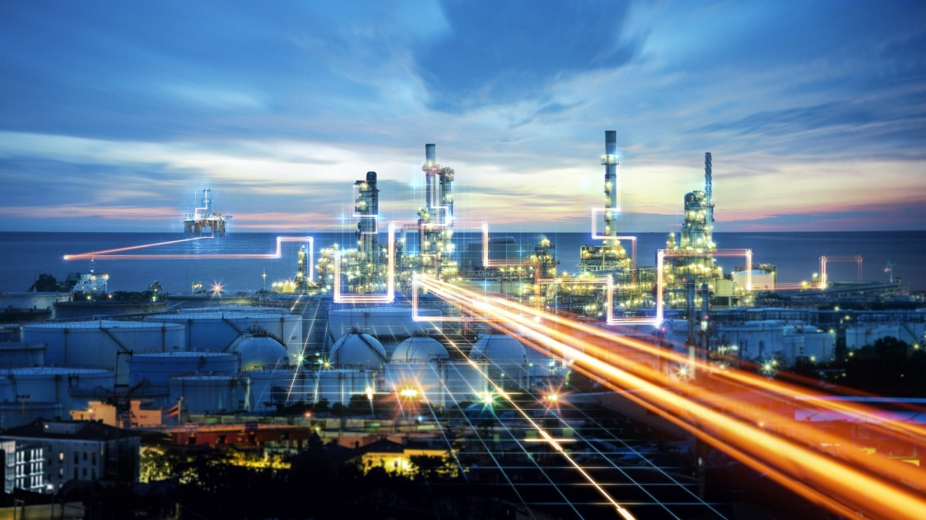

OBJECTIVES & GOALS

*PROBLEM DEFINITION*

Commodities are highly speculative, meaning massive potential upside but also the prospect of huge losses. A recent example, Tampa-based Optionseller.com citing volatile trading in natural gas and crude oil wiping out over $150,000,000 USD in one day’s trading causing all accounts to be liquidated (1). In many cases, too much hinges on uncertain government policies, in accurate data and producer reporting, poor research and structurally flawed investment products (described below) of the environment. This has led to a number of people moving assets into managed accounts, or passive investment vehicles (there has been an explosion in these types of structures on the equity side). These managed accounts are similar to investment vehicles, such as ETFs and ETNs, and are for derivative markets, structurally flawed. This is very different from an experience in the equity space. In the next section, we will offer a solution because this means that these current vehicles massively underperform the underlying commodities over time.

Even with all of the above, there seems to be renewed interest in commodity investing these days. Oil has been riding higher, not least due to ongoing/escalating tensions in the Middle East. *However*, a lot of research likes to exhibit charts like the one below. It shows the relative relationship between the levels of the S&P GSCI commodity index and the S&P 500 index of US stocks.

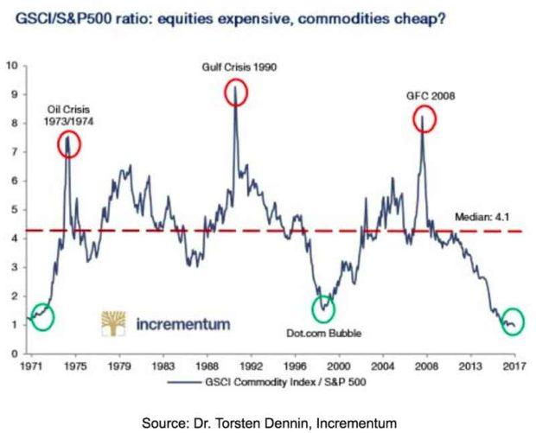

The idea is that when the line is ultra-low, such as now, it's a signal that commodities are cheap relative to stocks. The problem is that this is a ratio. It could just be signaling that stocks are expensive overall. (There are plenty of other flaws in it, but that's a whole project in itself.)

A popular way to invest in commodities is via some kind of index fund, such as an exchange-traded fund (ETF) or exchange-traded note (ETN). The commodity indices are all very different. Between different types of commodities, the supply and demand dynamics have nothing in common. However, speculative money flows can push all prices up or down, as investors pile into index funds, or dash for the exits. One person makes a great case for why oil is heading higher. Another uses solid reasoning to explain why it's going lower. Too often, it just seems like guesswork.

It's beyond the scope of this prospectus to explain the full, technical details. However, the problem is that index-tracking ETFs and ETNs do it by way of the futures market, a type of financial derivative. A future is a contract to buy something at a later date at an agreed price.

Investment funds don't want to take delivery of physical commodities, so they roll over the futures contracts before they expire. This means they sell the contracts that are close to expiry and buy longer-dated ones. Futures prices bake in something called "basis" on top of the current "spot" price of the underlying asset. Basis is the difference between the cost of owning an underlying asset (e.g. lost interest on foregone cash deposits invested and any storage costs) less the benefits of owning something directly (e.g. dividends on stocks and coupons on bonds).

In the case of commodity futures, there's no foregone income yield from owning the future instead of the physical. So, basis mainly consists of the cost side, or "cost of carry." This is because investors in commodities have a choice. They can either own the physical commodity, paying out cash and taking on storage expenses. Or they can enter into a futures contract, keeping the cash and any interest on it, and avoiding the storage costs. The basis element of the future's price keeps the economic pros and cons of both situations in balance.

Basis shrinks over time, as a future approaches expiry. As a result, the price of the future gets closer to the spot price, being the price to buy the underlying asset straight away.

When the commodity funds roll over their futures positions, this means they sell something with little basis in the price and buy something with more basis in the price. This means they're constantly locking in small losses at each rollover.

It's actually more complex than that, involving things called "contango" and "backwardation." Therefore, funds that rely on futures contracts have a flawed structure that accumulates losses over time.

*MAIN OBJECTIVE*

The main objective of this phase of the development of the hedge fund is to model the price movement and forecast of various. The group will use a variety of cutting edge and sophisticated machine learning algorithms along with comprehensive technical and fundamental review of the energy markets. The first goal is to produce a simple technical chart forecasting the trading ranges of energy futures products. Given the time constraints, the first phase will focus mainly on gasoline and heating oil futures. A dashboard will be created to not only give resistance guidelines on price, but trend indicators such as bullish or bearish. Below is a possible example of a future dashboard;

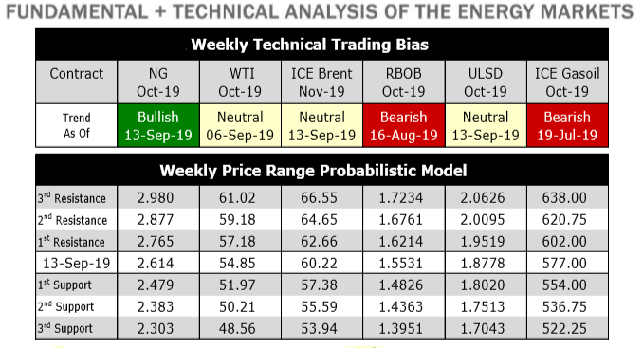

The next step will be to create a couple different trading strategies with the inputs being the probabilistic models developed and creating a back-testing harness to evaluate. The main goal is to deliver a strategy that is both quantifiable in terms of profitability but also within risk guidelines.

*PROJECT DELIVERABLES*

1. Detailed project initial findings report summarizing preliminary results
2. Detailed project final report summarizing all findings and recommendations
3. Full scale gasoline and heating oil futures price prediction modeling analysis
4. Summary dashboard of recommendation and back testing scenarios (possible configurable and run on demand (if time permits).

*PROJECT METHODOLGY*

In terms of workflow, this potentially can be a very complicated task; the workflow potentially will be modified depending complexity and feasibility:

1. Acquire the data
2. Preprocess the data
3. Process the data
4. Build the model – Linear regression and neural network (LSTM) seems to be popular on this type of data set.  Random forest to potentially classify the direction of the move in prices(bearish/bullish).
5. Test the model – train/test data sets
6. Build some type of back-testing system to test out a simple trading scenario.
7. Dashboard build

*PROJECT TIMELINE*

TEAM



**Andrius Markvaldas** has over 20 years of information technology and data management experience on a variety of different platforms.  Prior to joining Vertica, Andrius defined enterprise data strategies, as well as, built and managed world-class data capabilities for proprietary trading firms. His broad experience includes engineering large-scale multi-petabyte data systems with extreme performance requirements.

Andrius is currently in presales and solution architecture with Microfocus’ Vertica group.  His focus is in full lifecycle development and operation of Big Data systems in both financial services and social media advertising.  He holds a M.S. degree in Distributed Systems from DePaul University and is pursuing a M.S. degree in Predictive Analytics from Northwestern University.

REFERENCES

1. <https://www.bloomberg.com/news/articles/2018-11-19/hedge-fund-s-accounts-liquidated-amid-energy-market-volatility>
2. <https://seekingalpha.com/article/4174551-problems-commodity-funds>